Amos Goren,
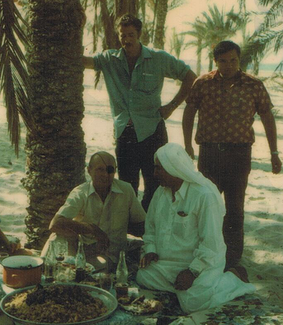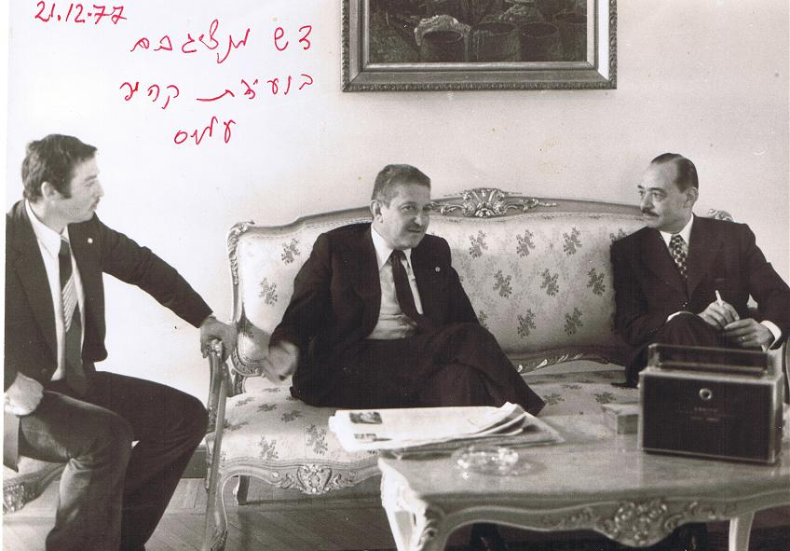
(Major res.) “Shaback, Mossad and Aman” veteran, Israeli intelligence services.
Boren in Kibbutz Hulata Israel
Paratrooper Officer, (Wounded 3 times in battles).
Sky Marshal in El-Al Airlines, “Mosad” Agent, Commanding VIP Security Unit for the Israeli Defense Ministers: M. Dayan, S. Peress, E. Weizman, Y. Rabin, A. Sharon & VIP Visitors as U.S Presidents. J. Carter & R. Nixon.
Commanding of reconnaissance unit in the 73 Yom Kipor War.
Intelligence Officer in the planning and executing of the Entebbe raid 76.
Security Manager of Computer Systems at the Israel Aircraft Industries.
Commanding of Intelligence unit in the 82 Lebanon War.
Security Officer for Israeli installations in the Caribbean and Canada.
CEO of Safe I. Ltd. Developing Intelligence, Information and Physical Security Systems.
President Front-Line Robotics Israel.
Founder & CEO Automotive Robotic Industry Ltd. Developed AMSTAF - Unmanned Ground Vehicle.
